Types of Inheritance in C++
Single inheritance: A derived class with only one base class is called single inheritance.
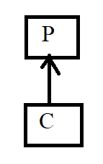
Multilevel inheritance: A derived class with one base class and that base class is a derived class of another is called multilevel inheritance.
tiple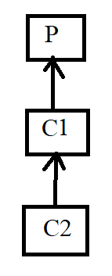 Inheritance
Hierarchical inheritance: Multiple derived classes with same base class is called hierarchical inheritance.
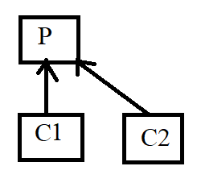
Multiple inheritance: A derived class with multiple base class is called multiple inheritance.
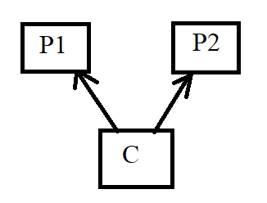
Hybrid inheritance: Combination of multiple and hierarchical inheritance is called hybrid inheritance.
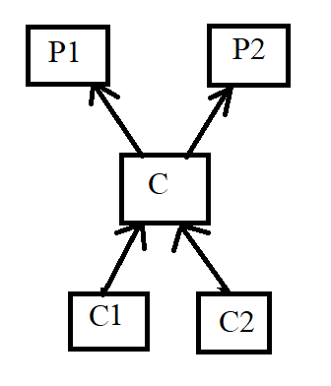
Multipath inheritance: A derived class with two base classes and these two base classes have one common base class is called multipath inheritance.
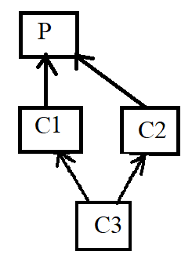

Modes of Inheritance in C++
Public mode: If we derive a sub class from a public base class. Then the public member of the base class will become public in the derived class and protected members of the base class will become protected in derived class.
Protected mode: If we derive a sub class from a Protected base class. Then both public member and protected members of the base class will become protected in derived class.
Private mode: If we derive a sub class from a Private base class. Then both public member and protected members of the base class will become Private in derived class.
